Video-conferencing
Rooms 321, 212, 115, 125, and the DCR have webcams and ceiling mics for videoconferencing.

In those rooms, access Zoom or other video-conferences through either the computer in the room or with an HDMI connected laptop to connect to the room webcam and ceiling mic (controls on the black panel).

811 Washington: Classroom Technology

Classroom Computers
All 9 classrooms have desktop computers built into the rooms.

Projecting
- There is a black console (or lectern cabinet) on the top of the black cabinet in each classroom.
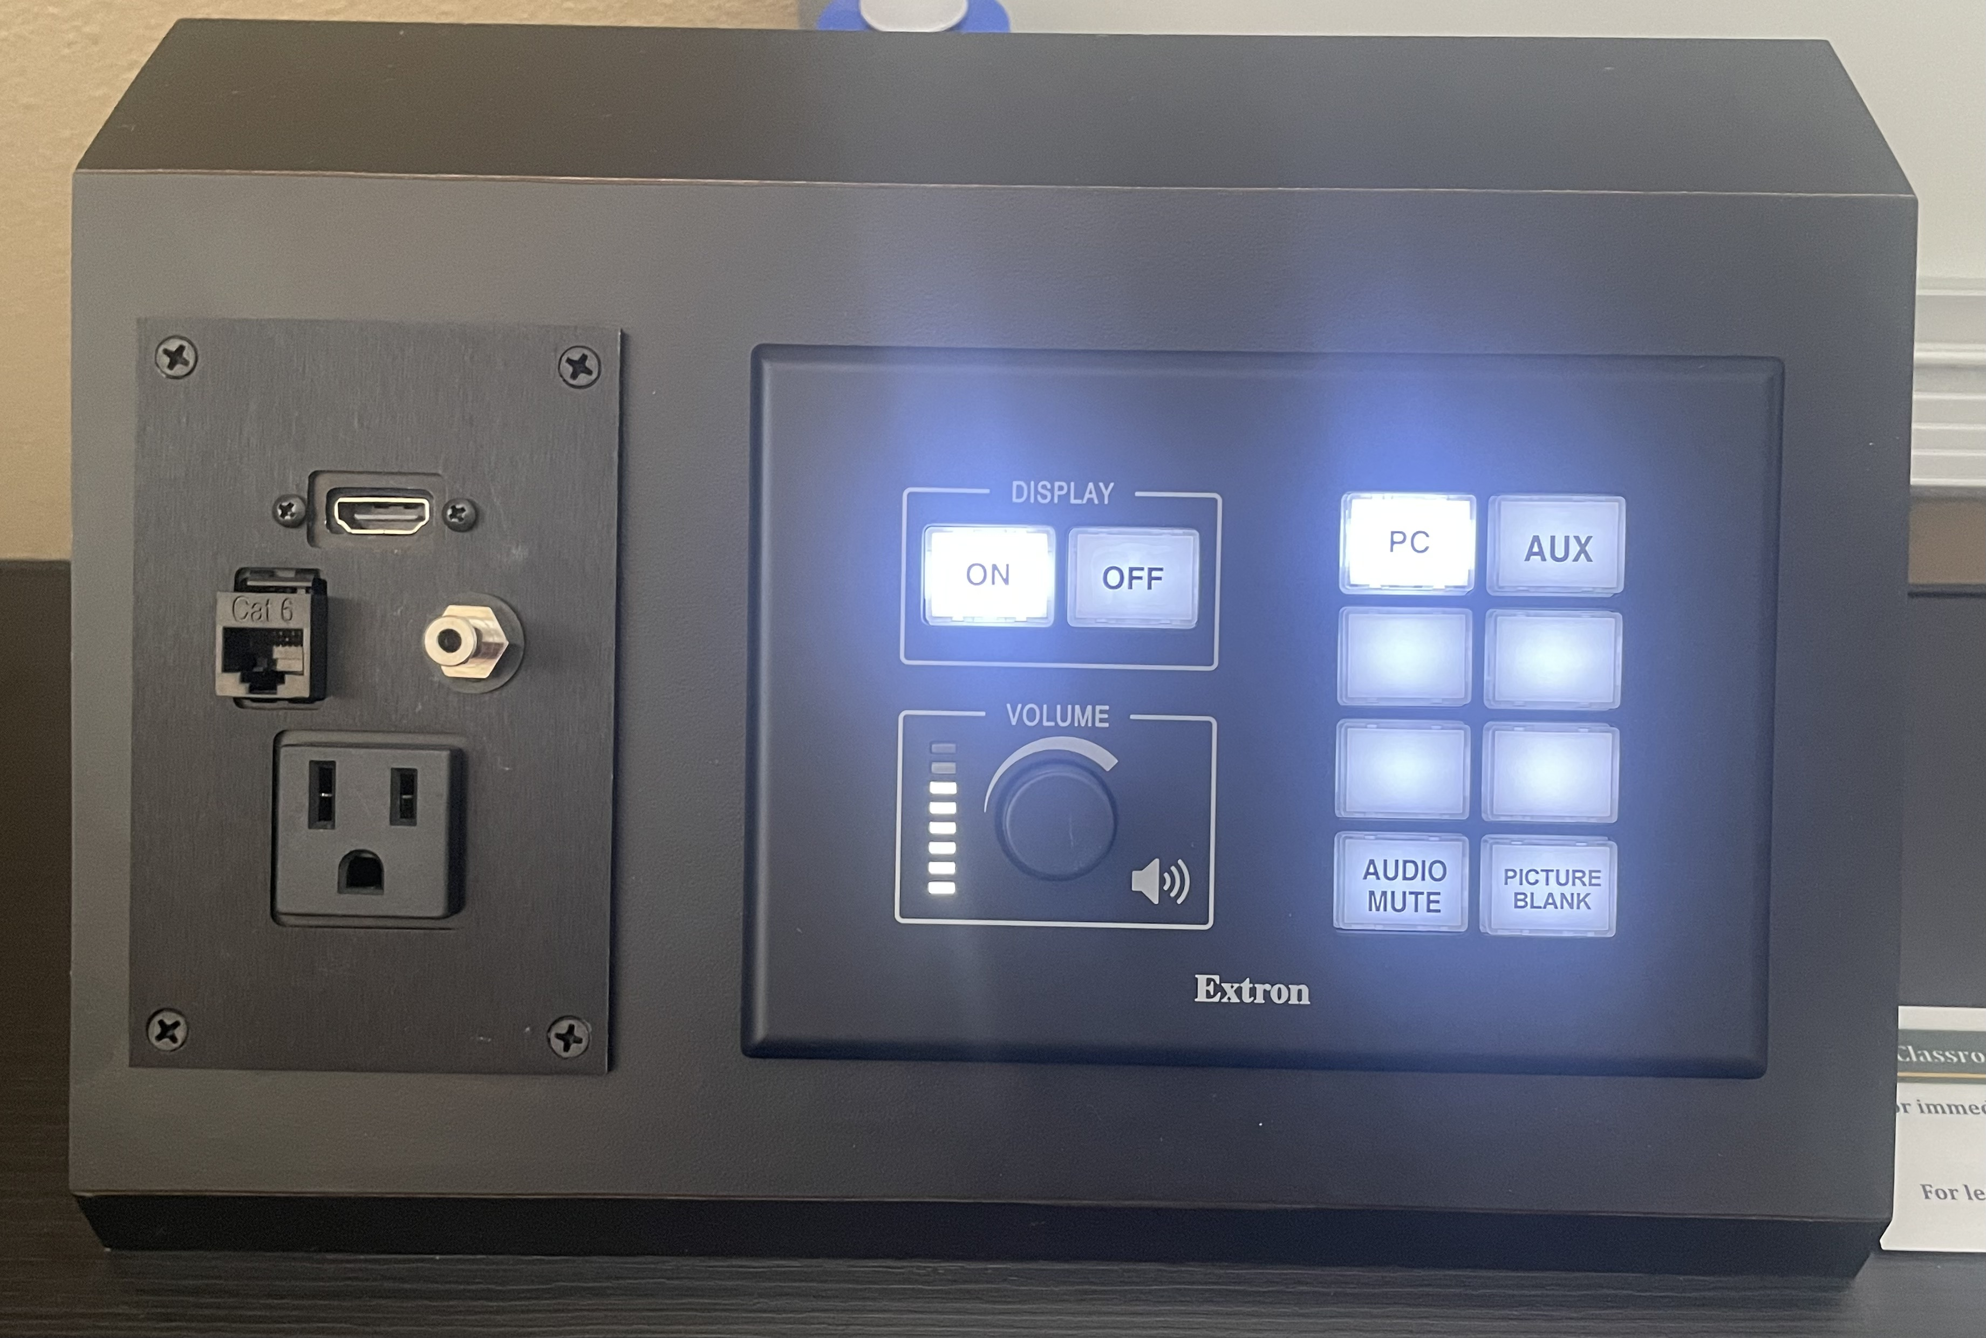
- Press “ON” on black console to turn on the projector and lower the screen.

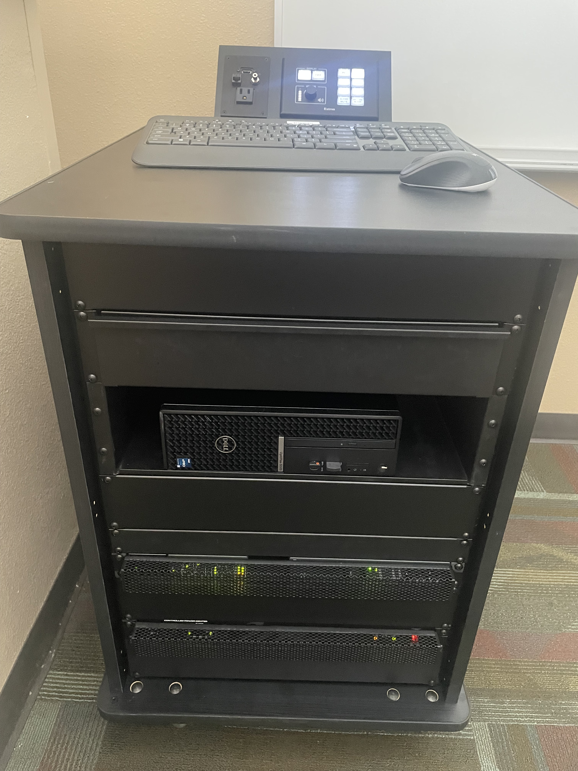
- To use room PC:
  - Press any key on the keyboard on the black console to awaken the PC in the cabinet. Logon to the computer using your Baylor ID.
  - The wireless keyboard & wireless mouse can be used anywhere in room (do NOT take them out of the room labeled on them).
  - A PowerPoint remote is also located in cabinet drawer.
  - You can plug your own USB or USB-C drive into the PC (located in the middle front of the black cabinet or side of the lectern monitor) so that you can load a PowerPoint or other documents onto the PC.
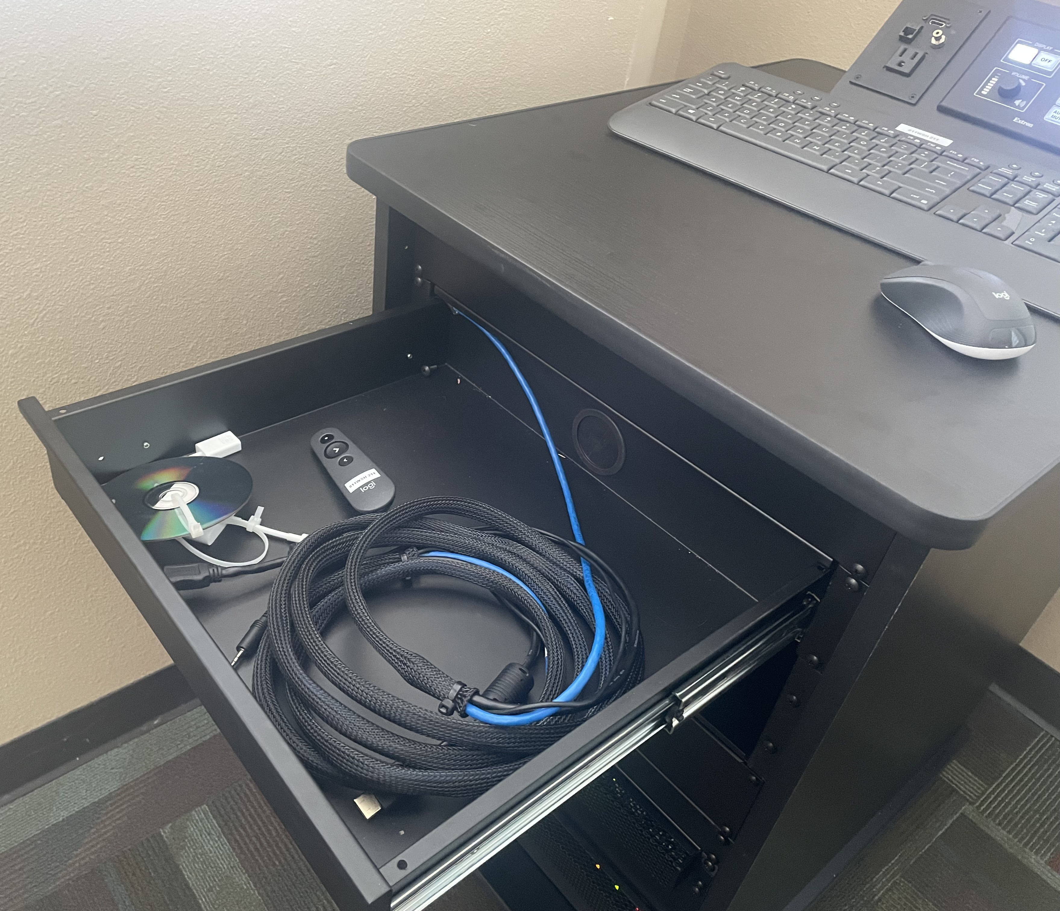
  - Be aware: the only monitor for the classroom PC in most rooms is the projector screen; anything on the desktop is projected for the whole room to see. If this is too problematic for you, it is recommended to bring your own laptop (which can be disconnected from the projector for privacy).
  - When finished with the PC:
    - logout of the PC,
    - press “OFF” on the black console,
    - return keyboard & mouse to the top of the black cabinet,
    - return PowerPoint remote to cabinet drawer,
    - and close cabinet drawer.
- To use a laptop:
  - Press AUX on black console.
  - Open the front top drawer on the small black cabinet.
  - Insert one end of the HDMI cable to the black console and the other to your laptop (use the USB-C adapter in the drawer if your laptop has USB-C but not HDMI).
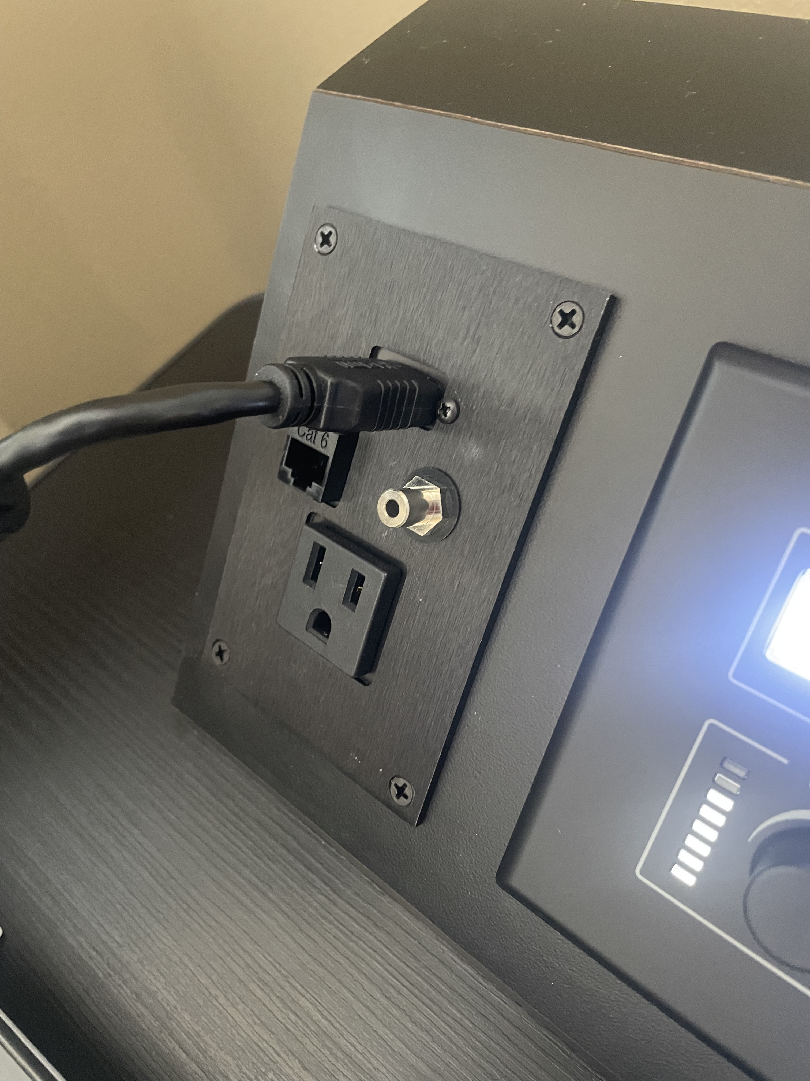
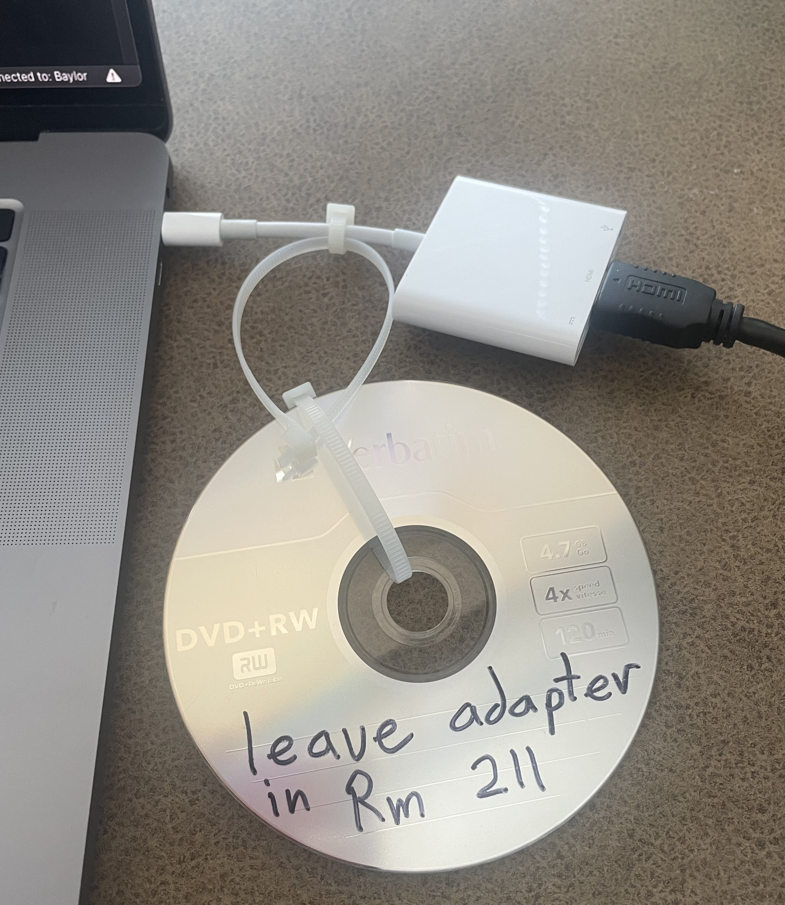
  - The PowerPoint remote will not work with a laptop.
  - When finished with laptop projection:
    - Press “OFF” on the black console.
    - Return HDMI cable (coiled) and USB-C adapter to cabinet drawer.
    - Close cabinet drawer.
- FYI: Only BU computers can connect to the network using the ethernet cord (blue cable bundled with the HDMI that can be connected to the black console).
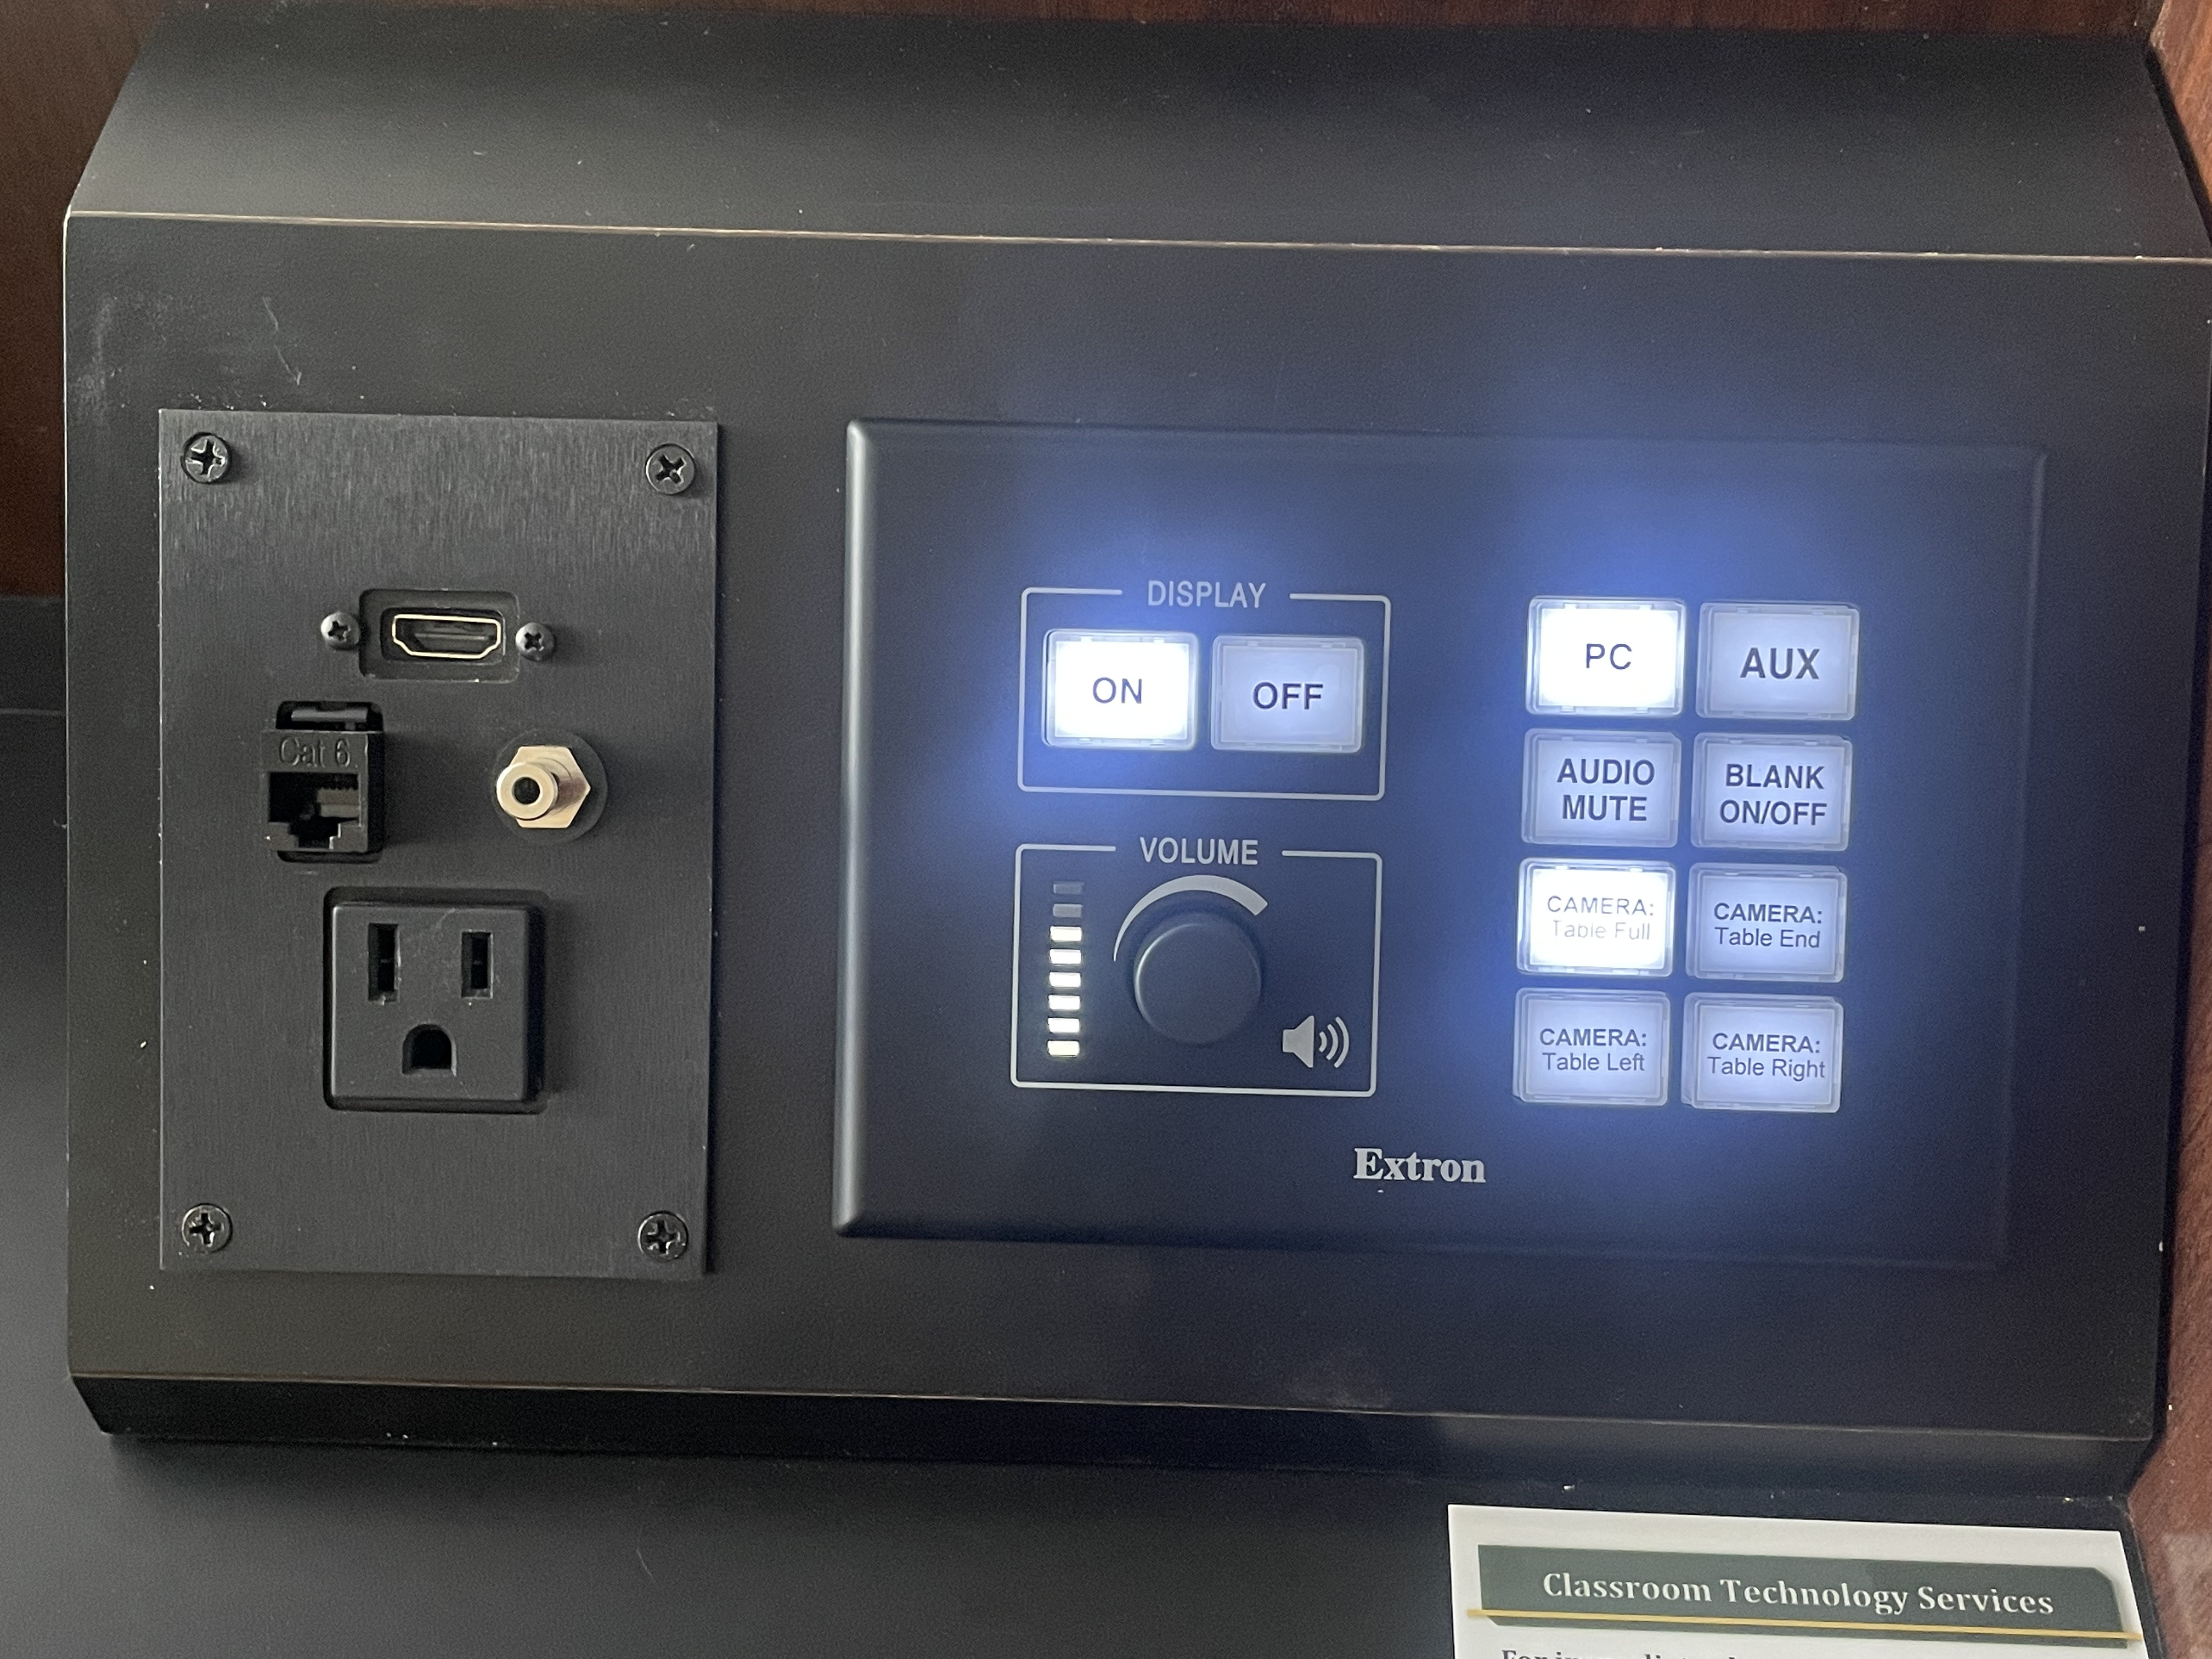
Sound
If you are having issues with sound, there is both a volume knob and an “AUDIO MUTE” button on the black console.
However, the computer/laptop also has volume/audio controls. Online players such as YouTube often also have their own volume controls. If any of these are turned down or muted, it could cause audio issues.

Display
Help
For classroom technology assistance, contact:

Jim Heston (jim_heston@baylor.edu)

or

Classroom Technology Services (254-307-1614)

Use the setting on the computer/laptop to switch between “Mirror” and “Extended” if multiple screens are used.

Room | Computer | Computer Monitor | Front Webcam | Back Webcam | Back TV Monitor | Ceiling Mic
115 | ✅ | ✅ |  | ✅ | ✅ | ✅
120 | ✅
125 | ✅ |  | ✅ |  |  | ✅
135 | ✅
211 | ✅
212 | ✅ | ✅ | ✅ |  |  | ✅
213 | ✅
320 | ✅
321 | ✅ | ✅ | ✅ | ✅ | ✅ | ✅

Updated 8-4-23

